MATHEMATICS METHODS

MAWA Semester 2 (Units 3 and 4) Examination 2017

Calculator-free

Marking Key

© MAWA, 2017
Licence Agreement
This examination is Copyright but may be freely used within the school that purchases this licence.
- The items that are contained in this examination are to be used solely in the school for which they are purchased.
- They are not to be shared in any manner with a school which has not purchased their own licence.
- The items and the solutions/marking keys are to be kept confidentially and not copied or made available to anyone who is not a teacher at the school. Teachers may give feedback to students in the form of showing them how the work is marked but students are not to retain a copy of the paper or marking guide until the agreed release date stipulated in the purchasing agreement/licence.

The release date for this exam and marking scheme is
- the end of week 1 of term 4, 2017

Section One: Calculator-free (52 Marks)

Question 1(a)
Solution

Marking key/mathematical behaviours | Marks
- correctly solves for . | 1

Question 1(b)
Solution

No,
This is not a discrete probability distribution as P(5) has a negative value and probabilities need to positive.

Marking key/mathematical behaviours | Marks
- recognises the properties of discrete probability distributions  - relates above property back to the question to justify answer | 1  1

Question 1(c)
Solution
$$μ=np=90$$
$$∴σ^{2}=6^{2}=36$$

$σ^{2}=np\left(1-p\right)$
$36=90\left(1-p\right)$ Expand and solve for p
$∴p=0.6$
$\frac{6}{10}n=90$ Sub value of p and solve for n.
Marking key/mathematical behaviours | Marks
- determines variance  - solves for parameter, p  - solves for parameter, n | 1  1  1

Question 2(a)
Solution
A census involves every member of the population being tested/questioned/investigated

Marking key/mathematical behaviours | Marks
- indicates the need to include every member of the population | 1

Question 2(b)
Solution
There would be no stoves left to sell as all of them would have broken down.

Marking key/mathematical behaviours | Marks
- indicates that there would be no items left for sale (no marks for cheaper or quicker) | 1

Question 2(c)
Solution
Use the unique serial numbers to select a random sample or similar

Marking key/mathematical behaviours | Marks
- indicates use of a suitable random selection method (based on serial numbers or other method) | 1

Question 2(d)
Solution
Using the list of the serial numbers, select every 400th stove

Marking key/mathematical behaviours | Marks
- indicates use of a suitable selection method | 1

Question 3(a) (i)
Solution
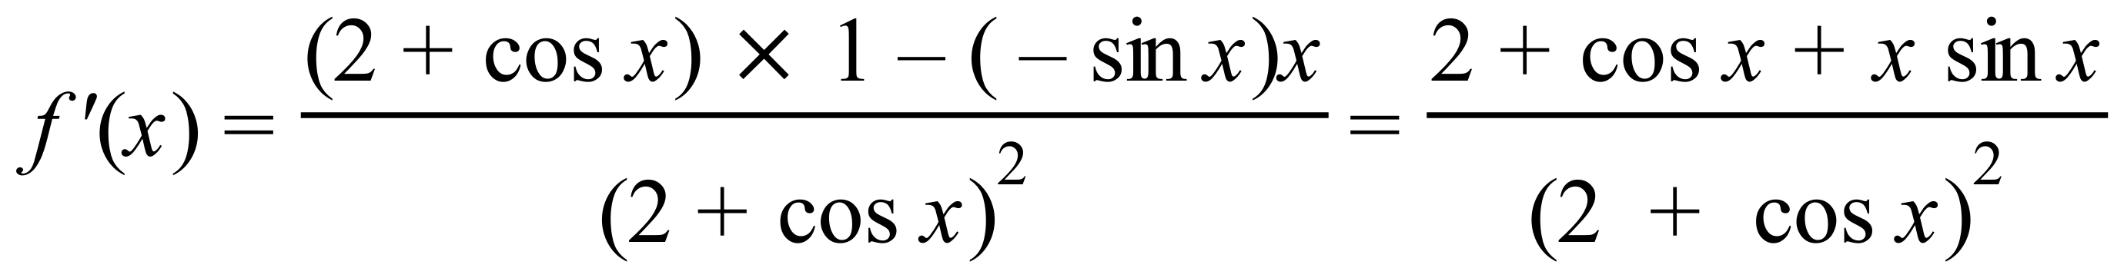
Marking key/mathematical behaviours | Marks
- correct use of the quotient rule  - differentiates correctly | 1  1

Question 3(a) (ii)
Solution
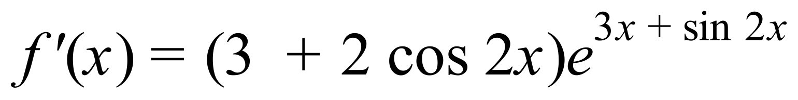
Marking key/mathematical behaviours | Marks
- correct use of the chain rule  - differentiates correctly | 1  1

Question 3(b)
Solution
Differentiating both sides: 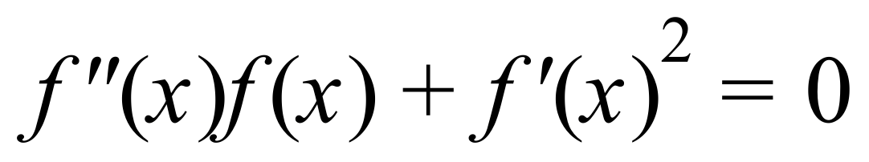
so 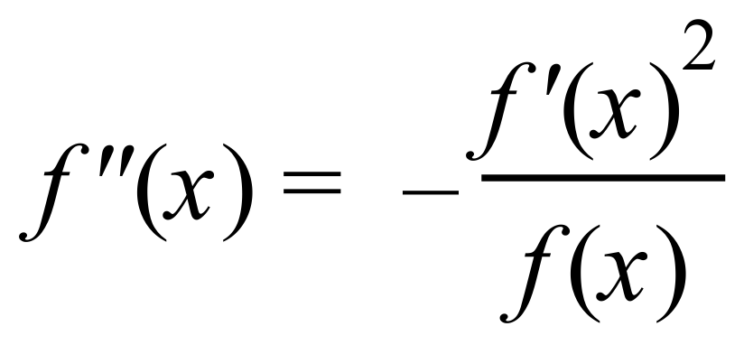
But 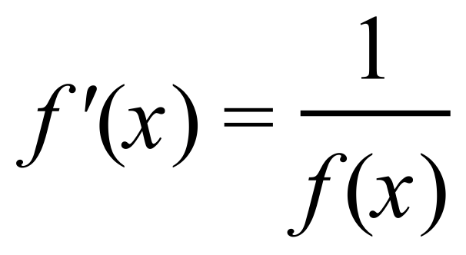 and so 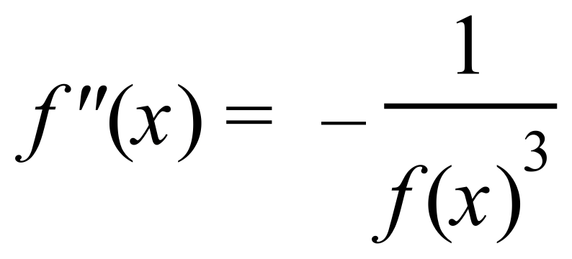 i.e. 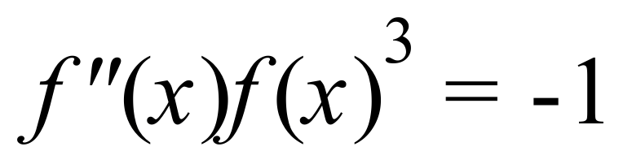
Marking key/mathematical behaviours | Marks
- uses product rule correctly  - obtains correct expression for 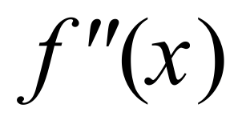  - replaces 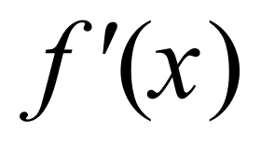 with 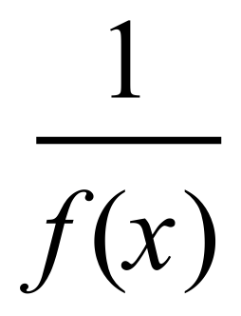 | 1  1  1

Question 4(a)(i)
Solution
Approximately 200 samples are involved

Marking key/mathematical behaviours | Marks
- States the number of samples (allow 190 to 210) | 1

Question 4(a)(ii)
Solution
Find the mean of the sample proportions, (from the graph) 0.4
May use sample proportion as an estimate of the population proportion
Marking key/mathematical behaviours | Marks
- identifies sample proportion as 0.4 (by reference to the graph or calculation)  - uses the sample proportion as an estimate for the population proportion | 1  1

Question 4(b)
Solution
- Survey is restricted to listeners of one particular station and therefore not representative of the population
- Survey is using a self-selection model and this indicates bias
- Timing may exclude some groups of people
- Access to a telephone is presumed
- People could respond more than once
- Nature of the question means football fans may be more likely to respond
Marking key/mathematical behaviours | Marks
- Lists one possibility  - Lists a second possibility | 1  1

Question 5
Solution
Note that:
Marking key/mathematical behaviours | Marks
- Recognises $\frac{f^{'}(x)}{f(x)}$  - Determines (or uses) derivative of denominator  - Uses constants to achieve numerator of -8x  - Finds integral accurately | 1  1  1  1

Question 6(a)
Solution
Since 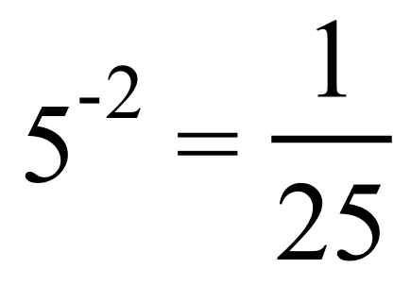 we have 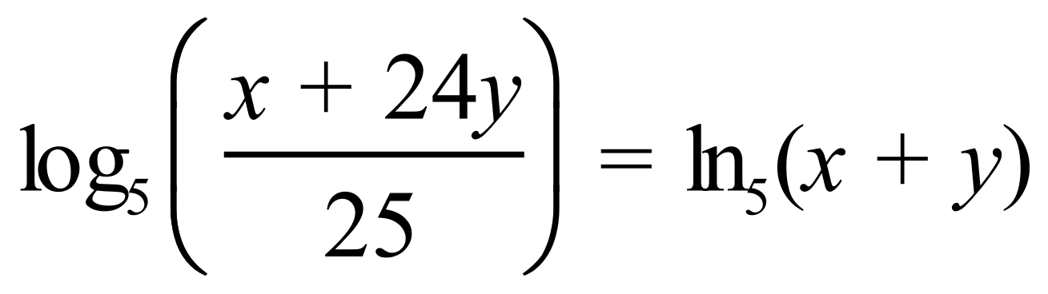 (#)
i.e. 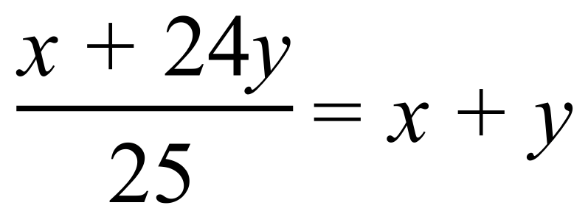 and hence 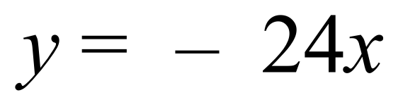
Marking key/mathematical behaviours | Marks
- Obtains equation (#) or equivalent  - Obtains correct answer | 1  1

Question 6(b)(i)
Solution
If 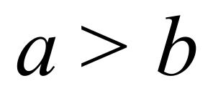 then 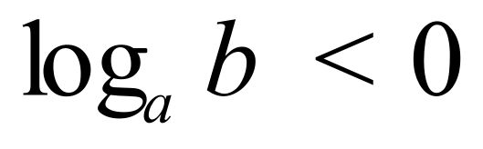 i.e. negative
Marking key/mathematical behaviours | Marks
- obtains correct answer | 1

Question 6(b)(ii)
Solution
If 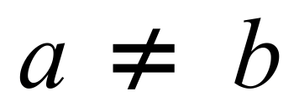 then 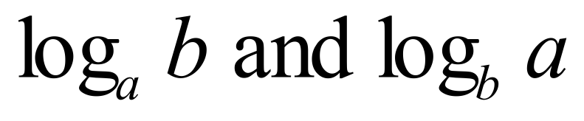 have opposite signs (#) and are unequal.
So 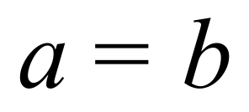 if 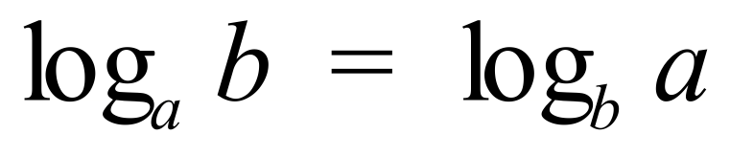
Marking key/mathematical behaviours | Marks
- deduces that  have opposite signs if   - complete proof correctly | 1  1

Question 7(a)
Solution
$A = -\int_{1}^{4}{(- \frac{8}{\sqrt{x}}} ) dx$
$= \int_{1}^{4}{\frac{8}{\sqrt{x}}} dx$

Marking key/mathematical behaviours | Marks
- sets up integral in either form | 1

Question 7(b)
Solution
$$A = \int_{1}^{4}{\frac{8}{\sqrt{x}}} dx$$
Marking key/mathematical behaviours | Marks
- integrates correctly  - correctly evaluates the integral | 1  1

Question 7(c)
Solution
$$\int_{1}^{a}{- \frac{8}{\sqrt{x}} dx = -25}$$
$⇒$ $-16\sqrt{a}+16= -25$
$-16\sqrt{a} = -41$
$a= \frac{{41}^{2}}{{16}^{2}}$

Marking key/mathematical behaviours | Marks
- correctly states the equation to be solved  - solves for a | 1  1

Question 8(a)
Solution
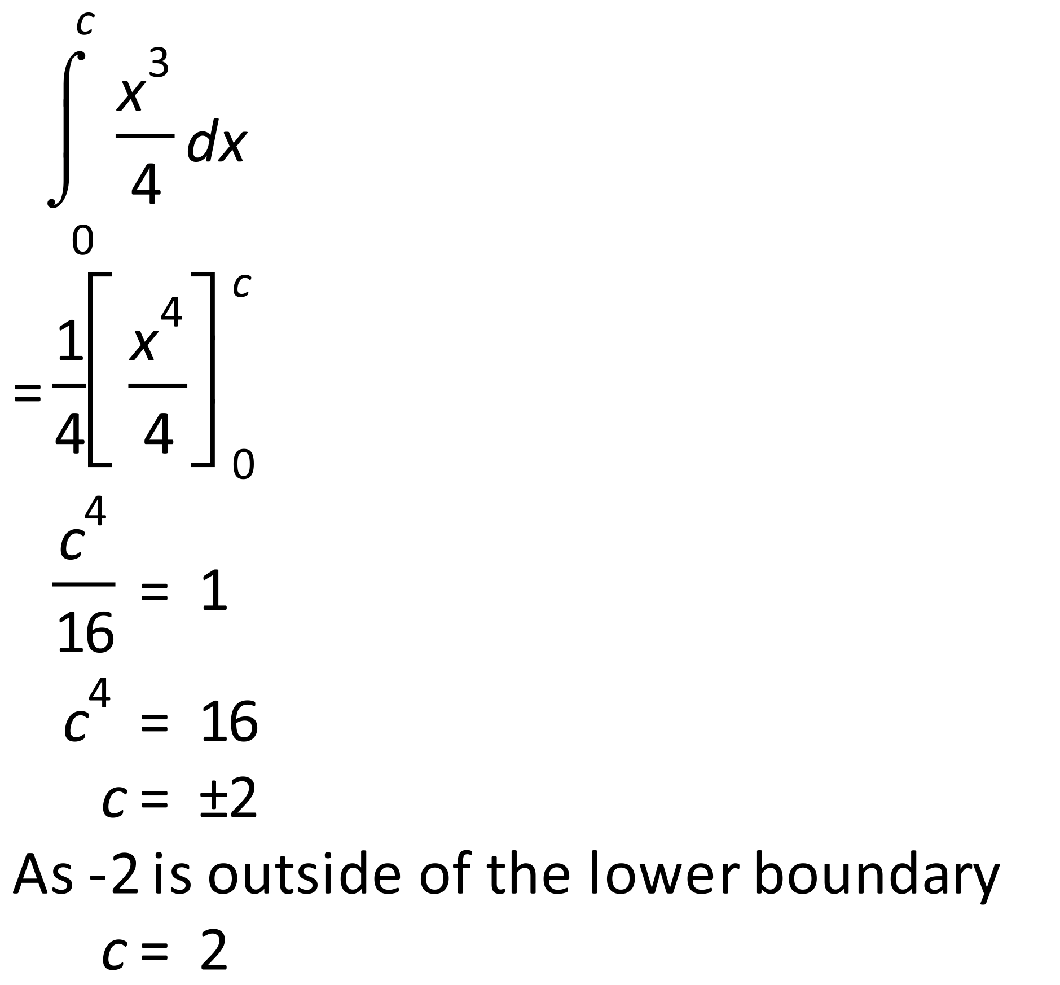
Marking key/mathematical behaviours | Marks
- uses the correct integral  - equates the pdf to one and solves for c  - Clearly states why has been rejected | 1  1  1

Question 8(b)
Solution
Marking key/mathematical behaviours | Marks
- Substitutes into the correct formula  - Integrates correctly and arrives at the required answer | 1  1

Question 8(c)
Solution
(i) From the graph, read the relative frequencies for the parking times (0,30] mins and (30, 60] mins Pr (at most 60 minutes) = 0.38 + 0.42 = 0.8.

(ii) relative frequency of vehicles parked between 1 and 1.5hrs = 0.14.
200 x 0.14 = 28 vehicles.

(iii) Answers will vary.
One possible answer: The data shows that 80% of the vehicles are parked for at most 60 minutes. Businesses that would tailor to this time length could be a nearby café or a mini mall with a few necessities stores (ie. Grocery store, bakery, pharmacy, clothing shop).

(iv) Answers will vary.
One possible answer: On which day of the week was the data collected?

Marking key/mathematical behaviours | Marks
- sums the two relative frequencies required  - multiplies the relative frequency by the total number of parked cars  - links to a type of business requiring less than 1 hour of parking  - links question to day of the week or other plausible variable. | 1  1  1  1

Question 9(a)
Solution
Since the graph has a vertical asymptote at 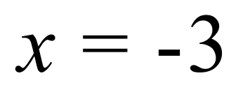 , 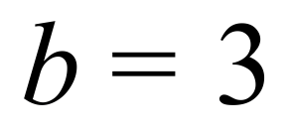
Since the point 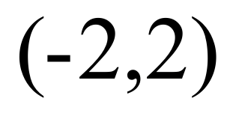 lies on the graph, , i.e. 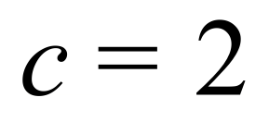
Since the point 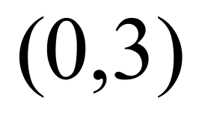 lies on the graph, , i.e.
and hence 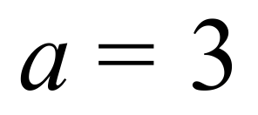
Marking key/mathematical behaviours | Marks
- evaluates 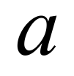 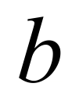 and  correctly | 1, 1, 1

Question 9(b)
Solution

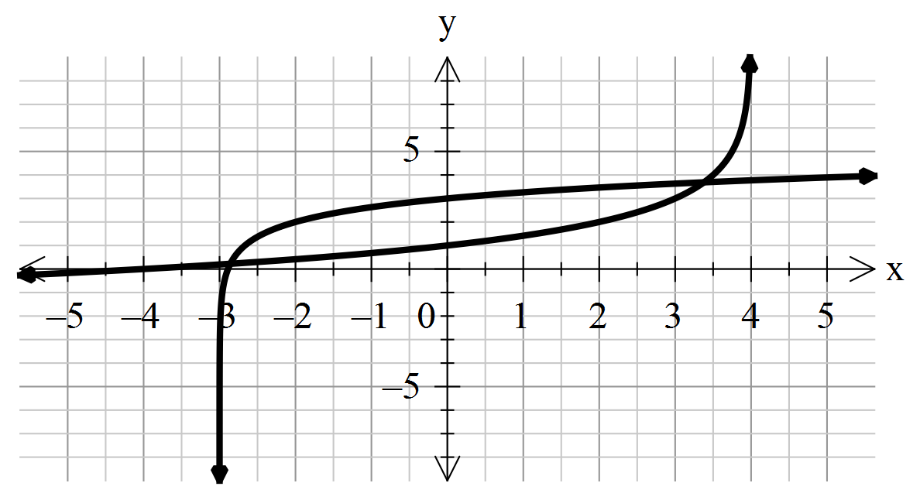
Marking key/mathematical behaviours | Marks
- asymptote at 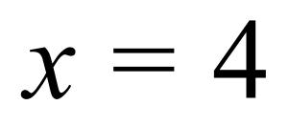  - 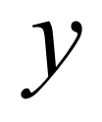 intercept at 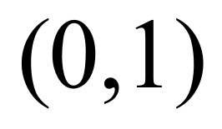  -  intercept at 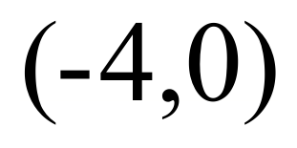  - graph of standard logarithm function reflected in both axes | 1  1  1  1

